AI Text Preprocessing Project Report
Student Name: Raja Ashar Ali Khan
Student ID: BAI241047
Course: Programming For AI
Project Title: AI Text Preprocessing Project

1. Introduction
This project focuses on text preprocessing of IMDb movie reviews for natural language processing (NLP) tasks.
Text preprocessing is an essential step before applying machine learning or AI models because raw text often contains noise, irrelevant data, and inconsistent formatting. Cleaning and standardizing text improves model performance, especially for tasks like sentiment analysis or text classification.
2. Dataset
The dataset used in this project is a mixed set of IMDb movie reviews.
For GitHub submission, a smaller cleaned version (cleaned_mixeddata_small.csv) was created to reduce the file size below 25 MB.
Columns in the dataset:
- rating : Original movie rating given by the reviewer.
- review :Original review text.
- clean_review :Text after preprocessing.
3. Preprocessing Steps
The following preprocessing steps were applied to the dataset:
- Lowercasing: All text is converted to lowercase to maintain uniformity.
- URL removal: Any links or URLs in the reviews are removed.
- Special characters removal: Only alphabets and spaces are kept; punctuation, numbers, and symbols are removed.
- Stopwords removal: Common words like "the", "is", "and" that do not add meaning are removed to reduce noise.
- Output: The cleaned text is stored in a new column clean_review in the CSV file.
4. Files in the Repository
- cleaned_mixeddata_small.csv: Smaller cleaned dataset ready for AI model usage.
- text_preprocessing.py: Python code used to clean the full dataset.
- make_small_csv.py: Python code to create the smaller CSV for GitHub.
- README.md: Project explanation.

5. Usage
- The cleaned dataset can be directly used for AI/ML tasks such as sentiment analysis or text classification.
- Python code files can be run to reproduce the preprocessing or generate a smaller dataset if needed.

6. Notes
- The preprocessing is implemented in Python using pandas and regular expressions.
- Stopwords are hardcoded, so no internet connection is required to run the code.
- This project demonstrates the importance of data cleaning in natural language processing pipelines.

Repo:
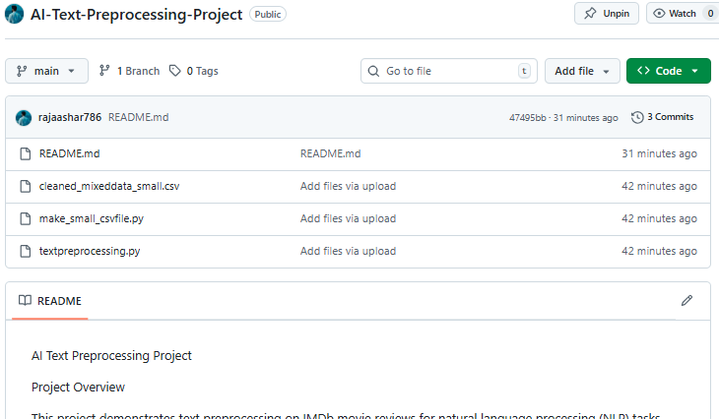

Github Readme Screen Shot:
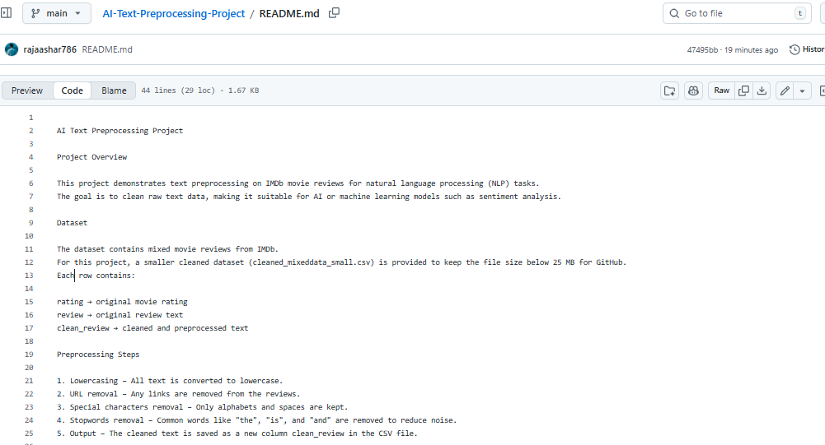

Output Of Cleaned Dataset:
